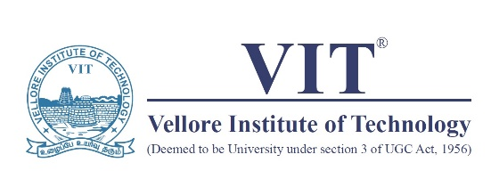

Report on Career Opportunities

**Name of the Student:** Vidhi P Shah

**Registration Number:** 21BCE1297

**Programme:** Bachelor of Technology in Computer Science and Engineering

**School:** School of Computer Science and Engineering (SCOPE)

**Learnings from the webinar “Career Opportunities” held on 18.9.2021 from 11 AM to 12.30 PM**

The School of Computer Science and Engineering VIT Chennai conducted a webinar on **Career Opportunities** to introduce students to the opportunities provided by the IT Service companies.

**Mr Tushar Phadnis**, Senior Director at Cognizant Technology Solutions Pune, was the resource person for the webinar. His experience of 24 years in the field gave us valuable insights into the working of IT Service companies and the values we need to incorporate to achieve growth in the sector.

The three major points he focussed on were:

* What does the IT Sector do?
* What opportunities can we avail of from it?
* What does the sector expect from us as its workforce?

**Growth, opportunities, and current scenario of IT Sector:**

The growing nature of the industry was made evident by the interwovenness of the IT sector with businesses and our daily lives. Real-world examples such as online education platforms and food delivery systems also indicate the growing opportunities in the IT sector.

He also explained the importance of every component of the IT sector towards its growth. The rapid growth of the industry is due to enormous investments in emerging technology. But without the telecom and IT solutions services, it would not be possible for everybody to avail the benefits of it. Also, software and hardware development should go hand in hand to execute modern technologies like AI, AR/VR, Data analytics, robotics and many more.

**Working of IT Services company and expectations from its work force:**

We were made familiar with the basic working structure of the IT Service Industries consisting of Market Domain led Verticals (Banking, Life Sciences, Retail, Manufacturing) and Technology led Horizontals (SAP, Analytics, Testing, BPO, Infra) along with an enormous staff of support functions.

The career path of an IT engineer presented by sir, made it clear that only **technical knowledge** is not sufficient to rise through a corporate company. **Communication and management skills** are equally important.

Thus, the expectations of IT companies from us includes everything from technical knowledge to communication skills, teamwork, positive attitude, leadership skills, productivity and much more. A disciplined and amicable colleague is preferred over an extremely talented but non-amicable colleague. The soft skills course provided by VIT is an excellent aid in developing these qualities.

**Learnings and Outcomes:**

As emphasized multiple times in the webinar, **our career is in our hands**. VIT University will continue to provide us with excellent opportunities but it is in our hands to avail maximum benefits from those opportunities.

Also important is to never stop learning and updating one’s knowledge. In coming years, many jobs will be terminated but many more will be created. The one who stops learning will never be relevant in today’s world and therefore never be successful.

For our resume to be marketable it is important to do certifications but also maintain a positive attitude towards learning and maintaining a healthy work environment.

It was a very interactive session. Sir patiently solved all our queries and encouraged us to move forward with our ideas to become a successful entrepreneur but also made us aware of all the things we need to keep in mind to run a successful business such as logistics, security and much more.

I would Like to extend my thanks to SCOPE VIT Chennai, Tushar sir, and all others who made this webinar possible. It was a very enriching experience.